Key for simple hypothesis testing  
one and two population tests

From ***“Biostatistical Design and Analysis – A Practical Guide”*** by **Murrary Logan**

1 a. Mean of single sample compared to a specific fixed value (such as a predictedpopulation mean) (one-sample t-test) . . . . . . . . . . . . . . . . . . . . . . . . . . . . . . . . . . . . . . . . . . . . . . . . . . . . . . . . . . . . . . . Go to 3

b. Two samples used to compare the means of two populations . . . . . . . . . . . . . . . . . . . . . . . . . . . . . . . . . . . Go to 2

2 a. Two completely independent samples (different sampling units used for eachreplicate of each condition) (independent samples t-test) . . . . . . . . . . . . . . . . . . . . . . . . . . . . . . . . . . . . . . . . . . . Go to 3

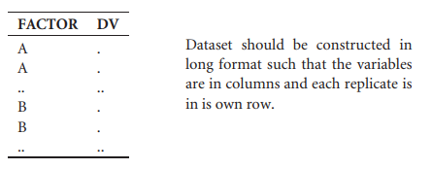

b. Two samples specifically paired (each of the sampling units measured under bothconditions) to reduce within-group variation (paired t-test) . . . . . . . . . . . . . . . . . . . . . . . . . . . . . . . . . . . . . . . Go to 3

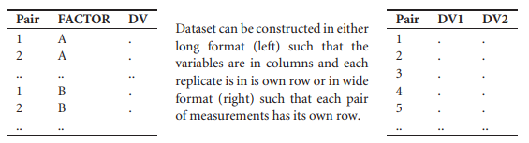

**3 a. Check parametric assumptions**

• **Independence of the samples; this is the base of t-test.**

• **Normality of the response variable at both level of the categorical variable -boxplots**

• *one-sample t-test*

• *two-sample t-test*

• *paired t-test*

*where* DV *and* Factor *are response and factor variables respectively.* DV1 *and* DV2 *represent the paired responses for group one and two of a paired t-test. Note, paired t-test data is traditionally setup in wide format.*

• **Homogeneity of variance (two-sample *t*-tests only) - boxplots (as above) and scatterplot of mean vs variance**

Parametric assumptions met . . . . . . . . . . . . . . . . . . . . . . . . . . . . . . . . . . . . . . . . . . . . . . . . . . . . . . . . . . . . . . . . . . . . . . . Go to 4

b. Parametric assumptions NOT met . . . . . . . . . . . . . . . . . . . . . . . . . . . . . . . . . . . . . . . . . . . . . . . . . . .. . . . . . . . . . . . . Go to 5

**4 a. Perform one-sample *t*-test**

**b. Perform (separate variances) independent-sample *t*-test** . . . . . . . . . . . . . . . . . . . . . . . . . . . . . . . . . . . . . . . . Done

• *one-tailed* (*H*0 : *µA = µB*); OR *one-tailed* (*H*0 : *µA > µB*)  
• *two-tailed* (*H*0 : *µA* = *µB*)  
*for pooled variances t-tests (see Later Notes)*.

**c. Perform (separate variances) paired *t*-test**. . . . . . . . . . . . . . . . . . . . . . . . . . . . . . . . . . . . . . . . . . . . . .. . . . . . . . . . . Done

• *one-tailed* (*H*0 : *µA = µB*); OR *one-tailed* (*H*0 : *µA > µB*)  
• *two-tailed* (*H*0 : *µA* = *µB*)  
*for pooled variances t-tests, (see Later Notes)*

**5 a. Attempt a scale transformation (see Table 3.2 for common transformations)** . . . . . . . . . . . . . . . . Go to 3

**b. Transformations unsuccessful or inappropriate** . . . . . . . . . . . . . . . . . . . . . . . . . . . . . . . . . . . . . . . . . . . . . . . . Go to 6

**6 a. Underlying distribution of the response variable and residuals is non-normal,   
yet known** . . . . . . . . . . . . . . . . . . . . . . . . . . . . . . . . . . . . . . . . . . . . . . . . . . . . . . . . . . . . . . . . . . . . . . . . . . . . . . . .See GLM Lectures

(remind me if I forgot to update in the later lectures)

**b. Underlying distribution of the response variable and residuals is non-normal,   
BUT is NOT known**. . . . . . . . . . . . . . . . . . . . . . . . . . . . . . . . . . . . . . . . . . . . . . . . . . . . . . . . . . . . . . . . . . . . . . . . . .. . . . . . . . . Go to 7

**7 a. Observations independent or specifically paired, variances not wildly unequal (Wilcoxon rank sum nonparametric test)** . . . . . . . . . . . . . . . . . . . . . . . . . . . . . . . . . . . . . . . . . . . . . . . . . . . . . . . . . . . . . . . . . . . . . . . . . . . Go to 8

**b. Variances not wildly unequal, random samples impossible (Randomization test)**  . . . . . . . . . . . . . . Done

**8 a. Perform one-sample Wilcoxon (rank sum) test**. . . . . . . . . . . . . . . . . . . . . . . . . . . . . . . . . . . . . . . . . . . . . . . . . . Done

**b. Perform independent-sample Mann-Whitney Wilcoxon test** . . . . . . . . . . . . . . . . . . . . . . . . . . . . . . . . . . . . . .Done

• *one-tailed* (*H*0 : *µA = µB*); OR *one-tailed* (*H*0 : *µA > µB*)  
• *two-tailed* (*H*0 : *µA* = *µB*)

**c. Perform paired Wilcoxon (signed rank) test**. . . . . . . . . . . . . . . . . . . . . . . . . . . . . . . . . . . . . . . . . . . . . . . . . . . . . . . Done

• *one-tailed* (*H*0 : *µA = µB*); OR *one-tailed* (*H*0 : *µA > µB*)  
• *two-tailed* (*H*0 : *µA* = *µB*)